

Application of ICT Lab
BS CYFS 2025
Lab Quiz
Name: Ibrahim Bin Arif
Roll no: 2503541

Submitted to : Miss Laraib Javaid

Quiz 2: Python AI Assistant
CLO1: Organize digital data using common software applications.
Write a Python program called “ai_assistant.py” that acts as a simple text-based assistant.
When the program starts, it should ask the user for their name and display a welcome message. Then enter a loop where the program keeps asking the user for input until they type exit.
Inside the loop, the assistant must:
- Detect at least three moods (happy, sad, angry) and give a different response for each.
- Respond to two common commands:
  - “time” → show the current time using the datetime module
  - “joke” → print any short joke
- If the message does not match any mood or command, print a default message like “I’m not sure I understand.”
When the user types exit, show a goodbye message and end the program.

Code:
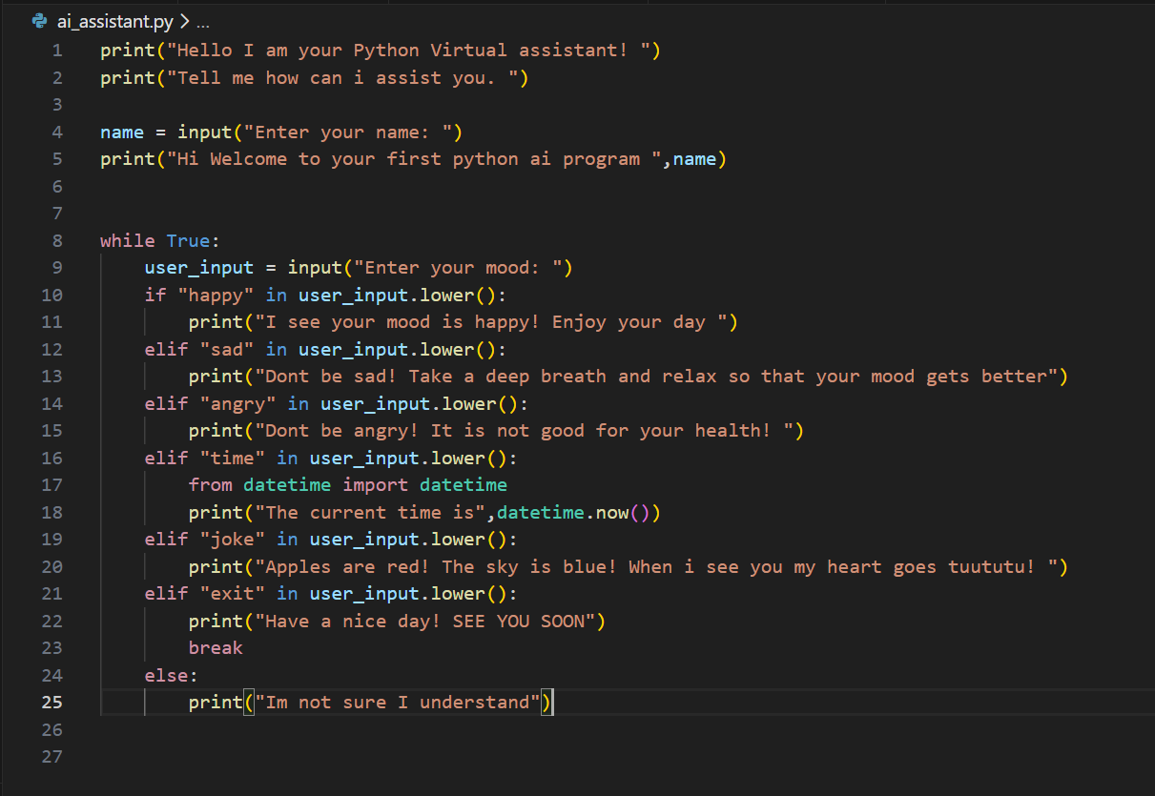
Output:
In this program the program will run until there exists a command that is defined in this program or it will run until and unless the user types exit . Following is output of moods.
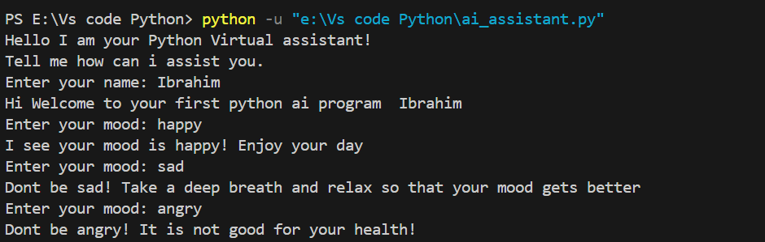
Now we will try the time command:
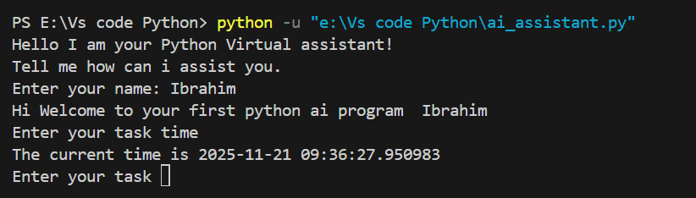
Now we will try the joke command:
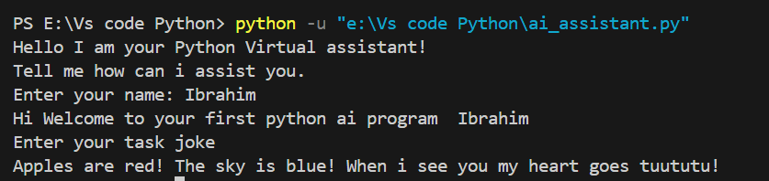
Now we will try a command that doesn’t exits and it will not recognize it:
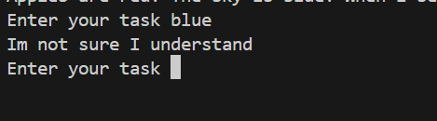

Finally we will use the exit command to break out from the loop
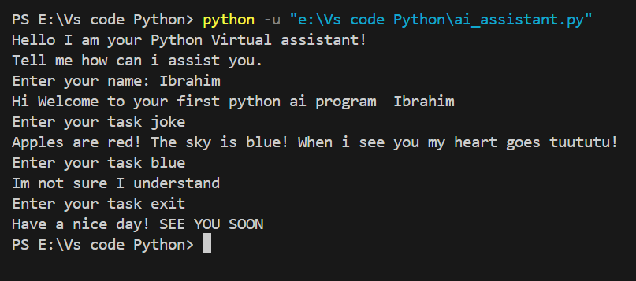

Task Done !

